Building oximeter using applications of transistors and operational amplifiers

Saifullah Tawsif, The Son Le
University of Sydney, NSW, Australia

Introduction
In this experiment, our aim was to design a simple blood oximeter using concepts and circuit designs learned about operational amplifiers, voltage, and current characteristics of LEDs and filter circuits. Blood oxygen level is a measure of oxygen concentration in the oxygen-absorbing protein hemoglobin in human blood [1]. The healthy range for oxygen level for humans is 95-100

Circuit design

Sensor circuit

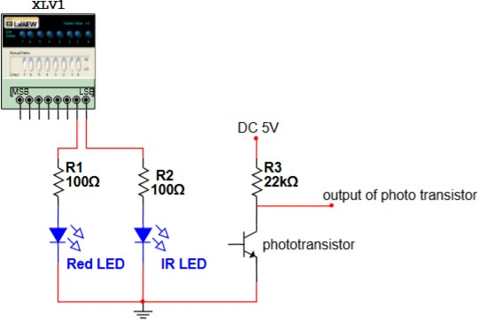

Figure 1: Circuit for an optical sensor with red and IR LED and photo transistor (source: ELEC2104 lab project manual)

Instead of using the digital input/output of the Elvis systems shown in the circuit, we powered each of the LEDs to the 5V DC supply, connecting each one individually when taking measurements and disconnecting the others. We obtained our initial readings of the currents directly from the circuit using digital multimeter probes connected in series:
- Red LED current: I_{Red} = 0.052 A
- IR LED current: I_{IR} = 0.089 A

Amplifier and filter design

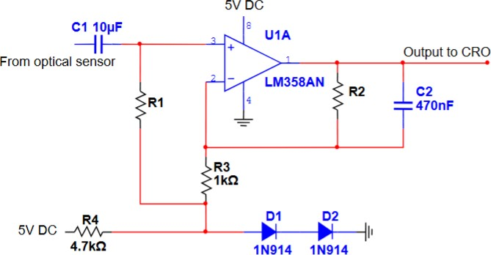

Figure 2: Filtering and amplifying circuitry (source:ELEC2104 lab project manual)

For the filter, we chose to let signals pass between the ranges from 1 to a maximum of 3 Hz. Given by
R
f =
60
where R is the heart beat and f is the frequency [2]. We chose the upper limit of the combined bandpass filter to 3 Hz because we noted that it would help remove some unwanted noise signals near the heart beat signals.
R1 is given by:

We chose the closest resistor at 18 kΩ.
1

2πR₁C₁

1

2πR₂C₂

= 1 Hz

= 3 Hz

Our R₂ was chosen to be 120 kΩ. Upon designing the amplifier, we attempted to test signal amplification by connecting the function generator input at 5 V with a frequency of 2 Hz from the Elvis instruments and observing the output on the oscilloscope [4] . However, although we saw the output, it was not pulsating. Only after we combined the amplifier circuit with the sensor circuit did we observe a pulsating waveform corresponding to the heartbeat.
We assume this may be due to the use of a Teletronix oscilloscope and LabVIEW instrument this time, which can display signals for more than 2 seconds. Initially, the signal was unstable due to poor solder connections, which we later corrected by applying better soldering techniques.
Additionally, we verified the connections at each part of the circuit using the multimeter’s continuity function, which does not require an input signal to detect whether an open circuit is present. The multimeter displays 0 if the circuit is closed and connections are secure.

Completed Circuit
Mechanical design of sensor circuit:

For the convenience of use of the oximeter, we needed to place the sensor circuit in a favorable position so that the transmitted lights could be properly directed throught the skin and to minimise external light. We did so by using an extended wire connection from our breadboard, and soldering the phototransistor, infrared led and red led to it. This allowed us to comfortably place our finger near the sensor while also using other fingers to isolate the system from outside light:
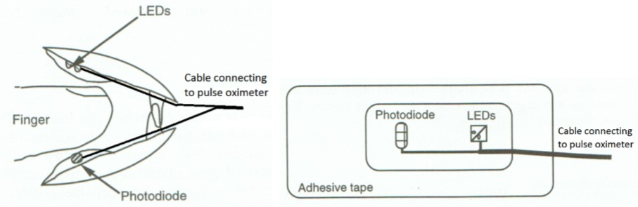

Figure 3: a) Clamp (or clip) type probe (b) Probe on adhesive tape (source:ELEC2104 lab project manual)

Components soldered to cable connection to make mechanical design more functional.
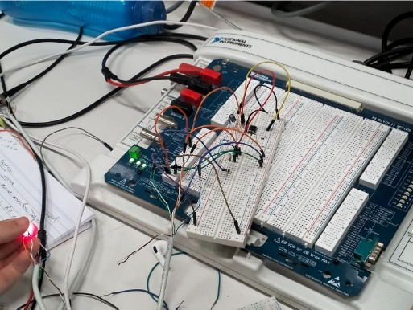
Figure 4: Final circuit

Data collection
Below is the oscilloscope view for signals from each of the LEDs:

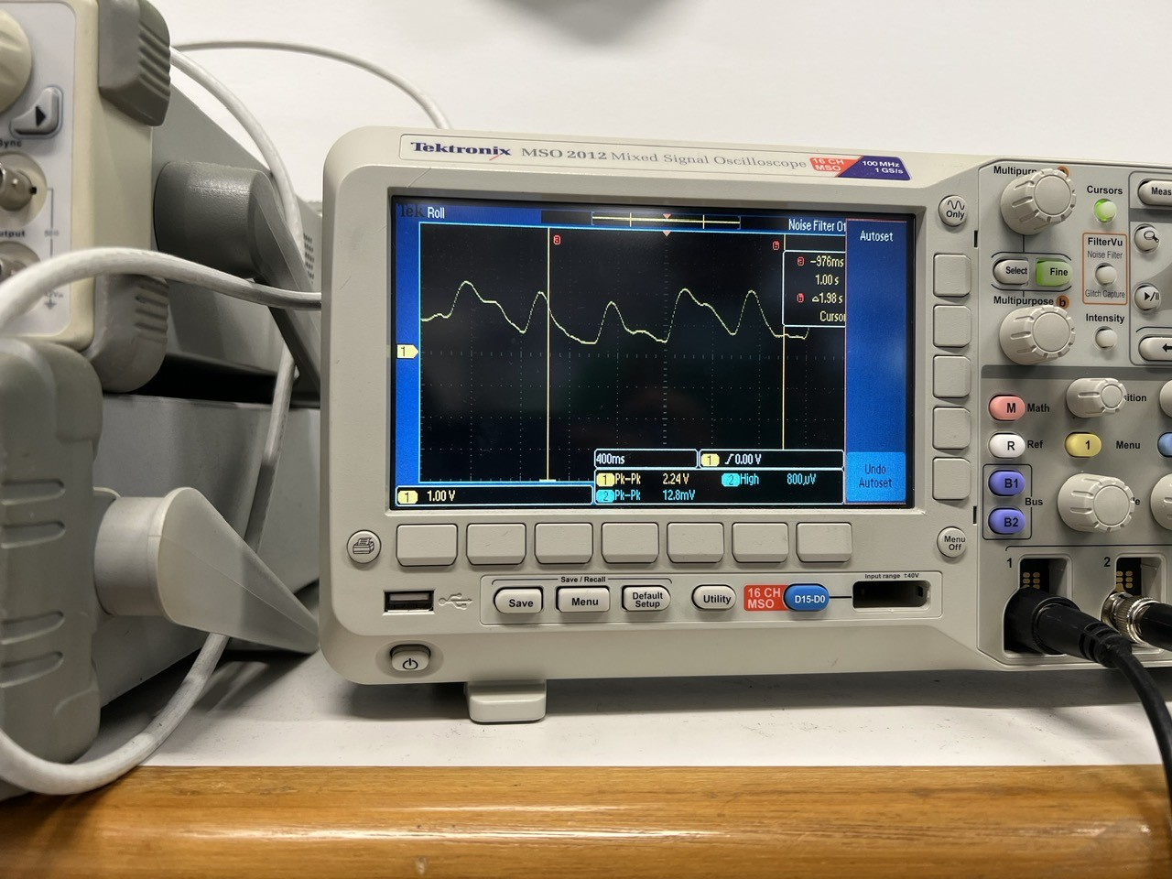

Figure 5: Red LED data

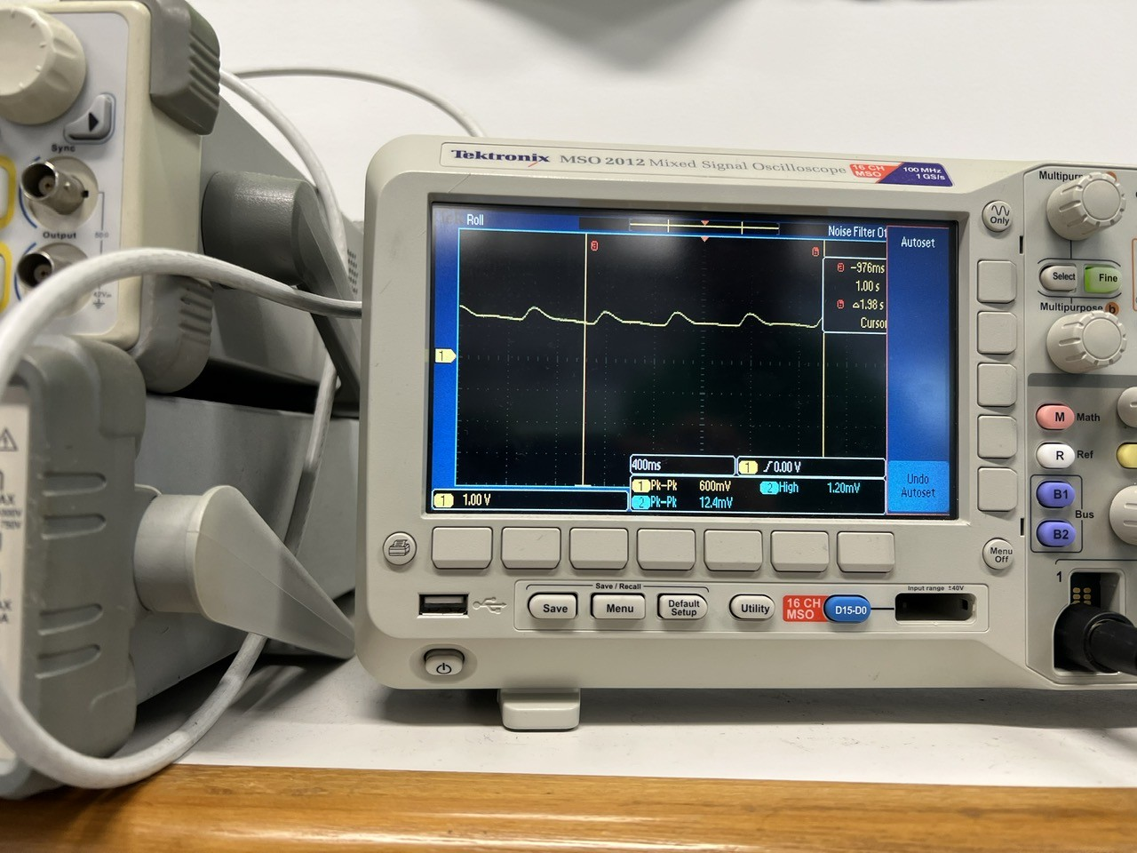

Figure 6: IR LED data

Then we tried to obtain the signals again and then simulated the waveforms in matlab to make measurements [3] :
Measurement parameters:
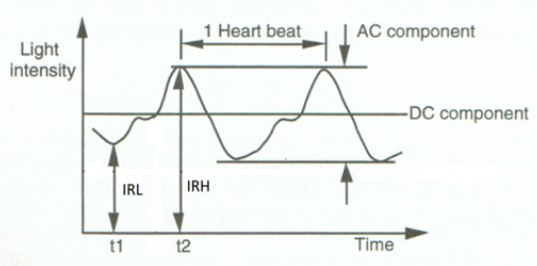
Figure 7: Data analyze

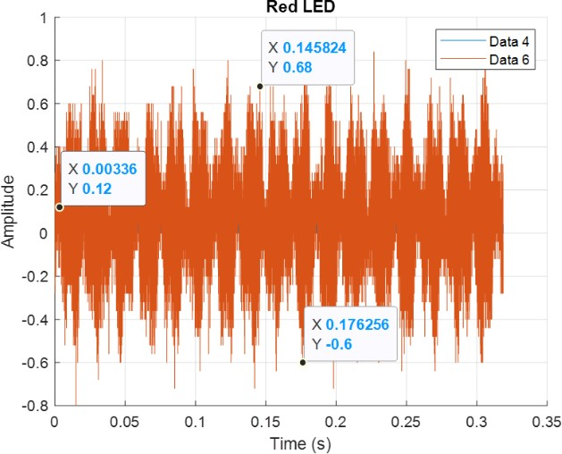

Figure 8: Red LED Data on MATLAB

We observed particularly high noise levels when capturing the signal for the red LED, and we had to use this waveform as it had some trouble displaying signals for a while.
The current for the red LED (I_{R}) is calculated as follows [5] :

I_{R} (AC) = 0.68 − (−0.6) = 1.28 A

I_{R} (DC) = 0.12 A

Figure 9: IR LED Data on MATLAB The IR LED signal was comparatively smoother.

The current for the IR LED (I_{IR}) is calculated as follows:

I_{IR} (AC) = 1.71 − (−1.32) = 3.03 A

The ratio R is given by:
I_{IR} (DC) = 0.21 A

R = i_{IR,} _{AC}/i_{R,} _{DC} = (1.28/0.12) = 0.74

iIR, AC/iIR, DC
(3.03/0.21)

The oxygen saturation S_{p}O₂ is calculated as follows:

S_{p}O₂
= 0.81 − 0.18R 100%
0.63 + 0.11R
×

= 0.81 − 0.18 × 0.65 100 = 95.14%
×
0.63 + 0.11 × 0.65
This is within the healthy range of 96% to 100%. However, when taking the MATLAB data, our red LED signal was slightly weaker, possibly due to ambient light, which may have contributed to a slightly lower percentage than expected.

Conclusion and improvements
Our measured oxygen level was just about above 95%, which falls within the range for healthy oxy- genated blood. While we limited our bandpass filter to only allow signals between 1 and 3 Hz to pass through to reduce interference from noise signals, there was still noticeable interference in our readings, as seen from the extra spikes around the waveforms.

To improve our model, we could add more effective filters by gaining a better understanding of the characteristics of the light waves and noise signals. Additionally, ambient light was not properly ac- counted for in our model. This could be addressed by using opaque materials shaped like a finger to isolate the sensor circuit extension and inserted finger from outside light, allowing for more accurate measurements of red and infrared signals received by the phototransistor.

Another improvement could be to receive the signals at the output of the amplifier as digital sig- nals through devices such as an Arduino Uno, and then plot the data for the waveforms in MATLAB. This would be more practical than using a full-scale oscilloscope, which is not logistically feasible.

In conclusion, this was a very informative and engaging project where we had the opportunity to apply concepts learned in our unit, such as the use of amplifiers and different filters to obtain useful signals. It has inspired us to pursue similar projects, using the skills we have learned on how the electrical components in our circuit can be applied to real-life applications.

References:
[1] Maziar Tavakoli, Lorenzo Turicchia, and Rahul Sarpeshkar, An Ultra-Low-Power Pulse Oximeter
Implemented With an Energy-Efficient Transimpedance Amplifier, IEEE TRANSACTIONS ON
BIOMEDICAL CIRCUITS AND SYSTEMS, VOL. 4, NO. 1, FEBRUARY 2010, pp27-38.
[2] Design of Pulse Oximeters, Edited by J G Webster, Department of Electrical and Computer
engineering, University of Wisconsin-Madison, Institute of Physics Publishing, Bristol and
Philadelphia.1997
[3] R. Finnerty, "How to Design a Better Pulse Oximeter," Systems Applications Engineer, Digital Healthcare Group, Limerick, Ireland, p. 5, Jun. 2021.
[4] A. Y. Song, "Bipolar Junction Transistors" and "Frequency Response, Op-Amps," [Lecture slides], Electronic Devices and Circuits, University of Sydney, Sydney, Australia, 2024.
[5]"Plotting Data," MATLAB Documentation, MathWorks. [Online]. Available: https://au.mathworks.com/help/matlab/data_analysis/plotting-data.html. [Accessed: Nov. 26, 2024].

